# Application Testing And Debugging Report

Testing 360 Home Décor(<https://360homedecor.uk/>)

**1.TC_CONTACT_FORM_01**

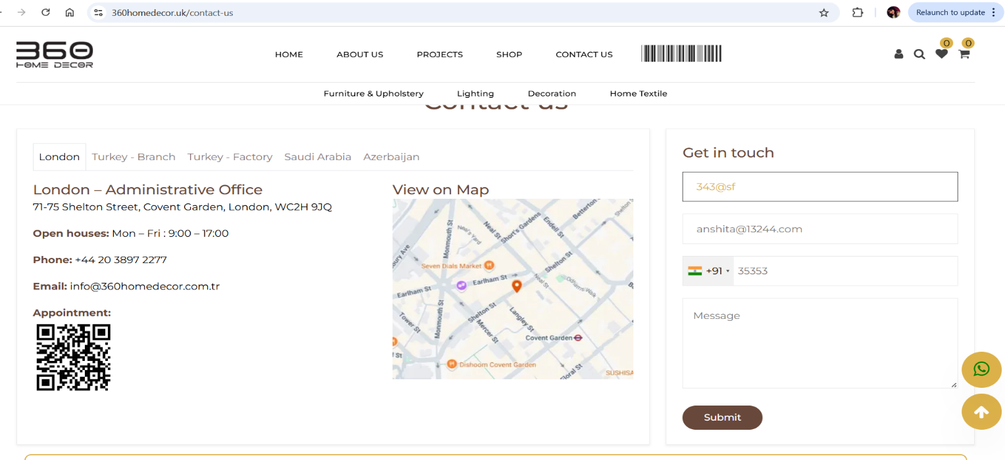

1.In Home Page the footer section “Contact Us “ page having an error.

<https://360homedecor.uk/contact-us>

**2.TC_FOOTER_02** <https://360homedecor.uk/contact-us>



**3. TC_REQUEST_INFO_03** <https://360homedecor.uk/contact-us>

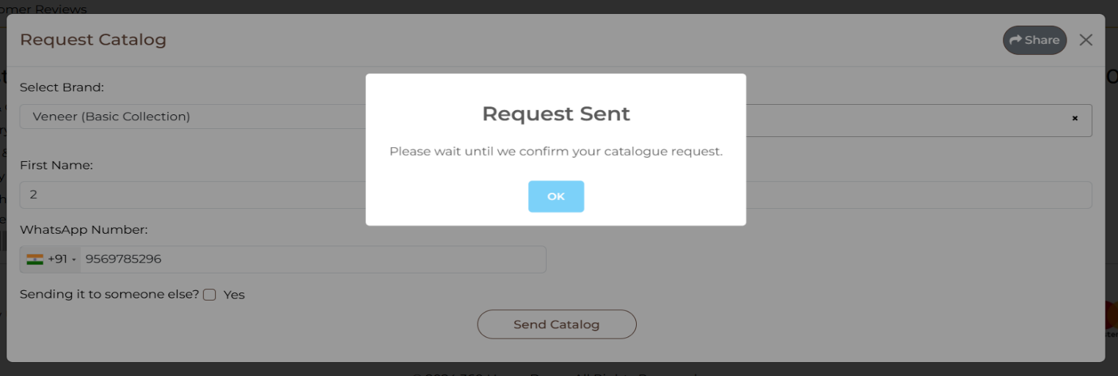

**4. TC_Appointment_01** <https://360homedecor.uk/contact-us>

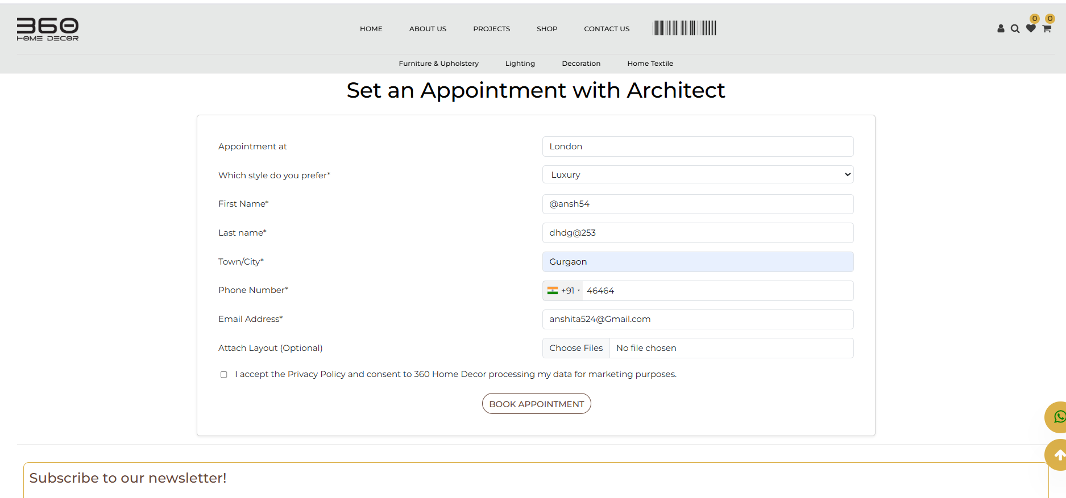

**5. TC_Appointment_03** https://360homedecor.uk/design-consultation

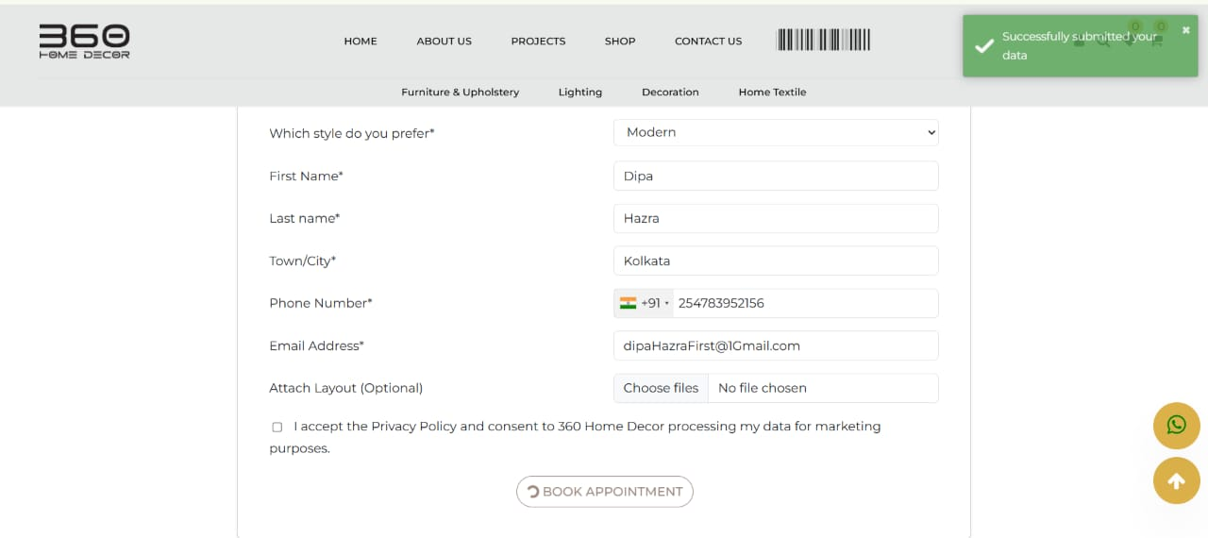

**6. Test Case ID-TC_Cart_01** https://360homedecor.uk/cart

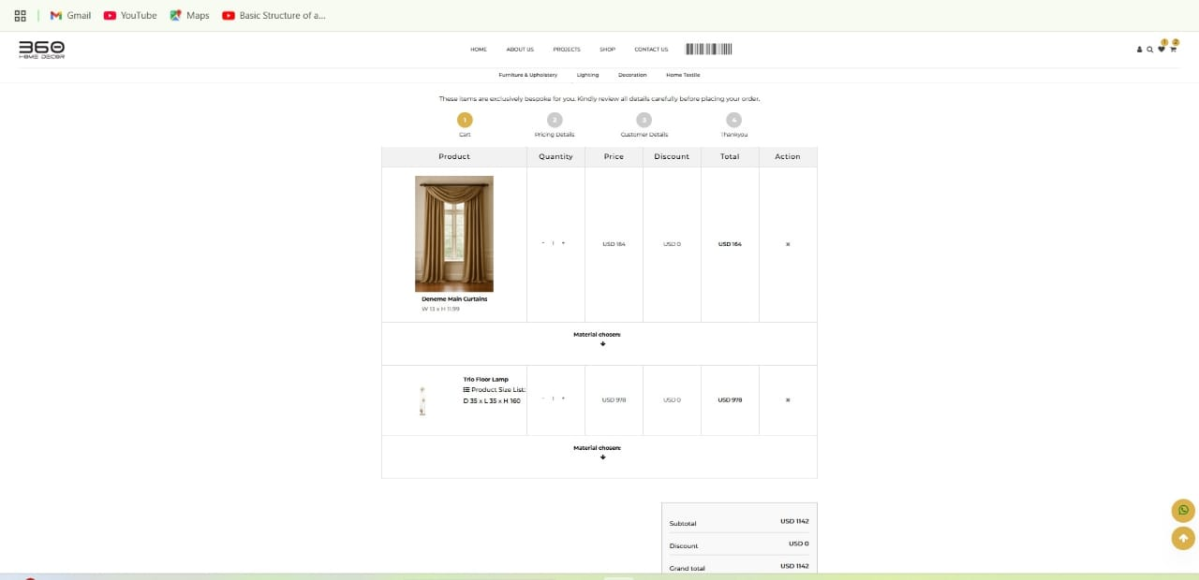

**7. TC_news Letter_Subscription** https://360homedecor.uk/home

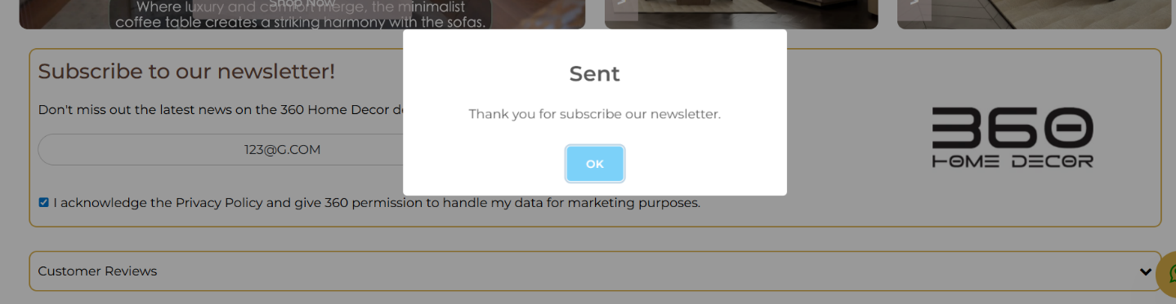

**8. TC_Customer_Review** <https://360homedecor.uk/career>

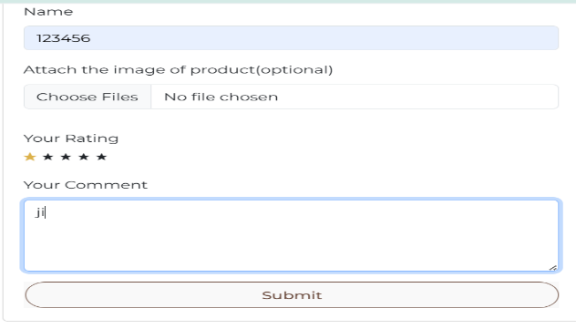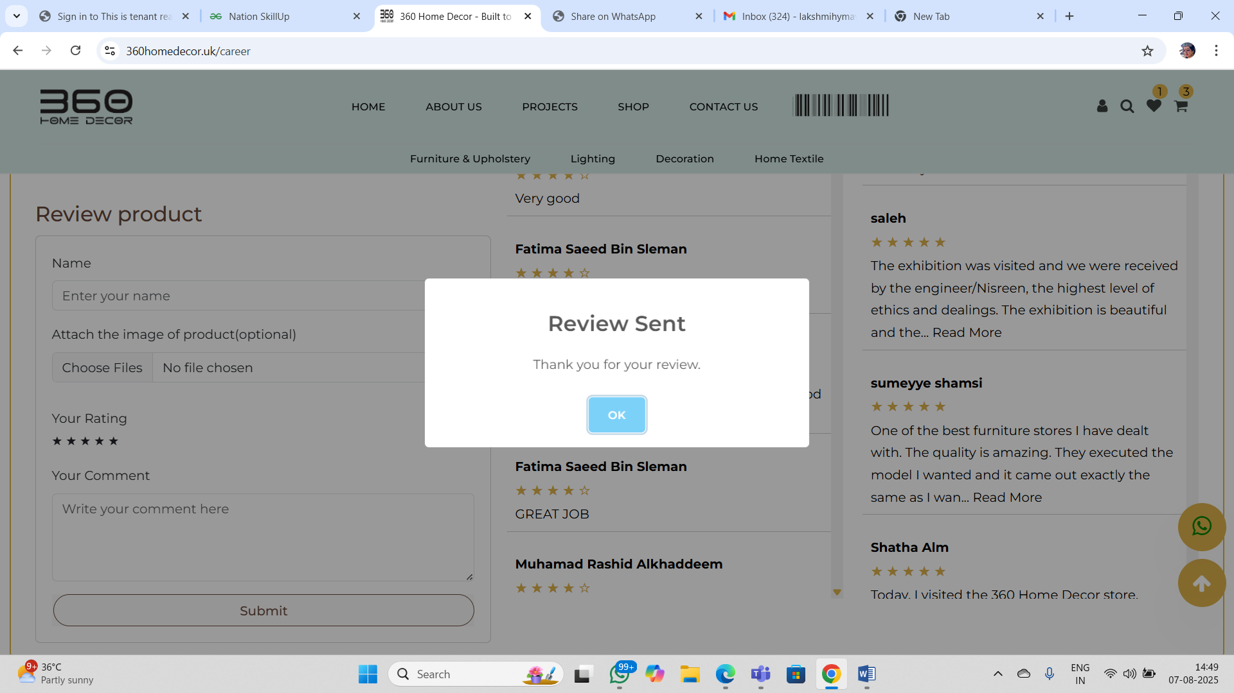

**9. TC_Request Catalog_01** <https://360homedecor.uk/design-consultation>

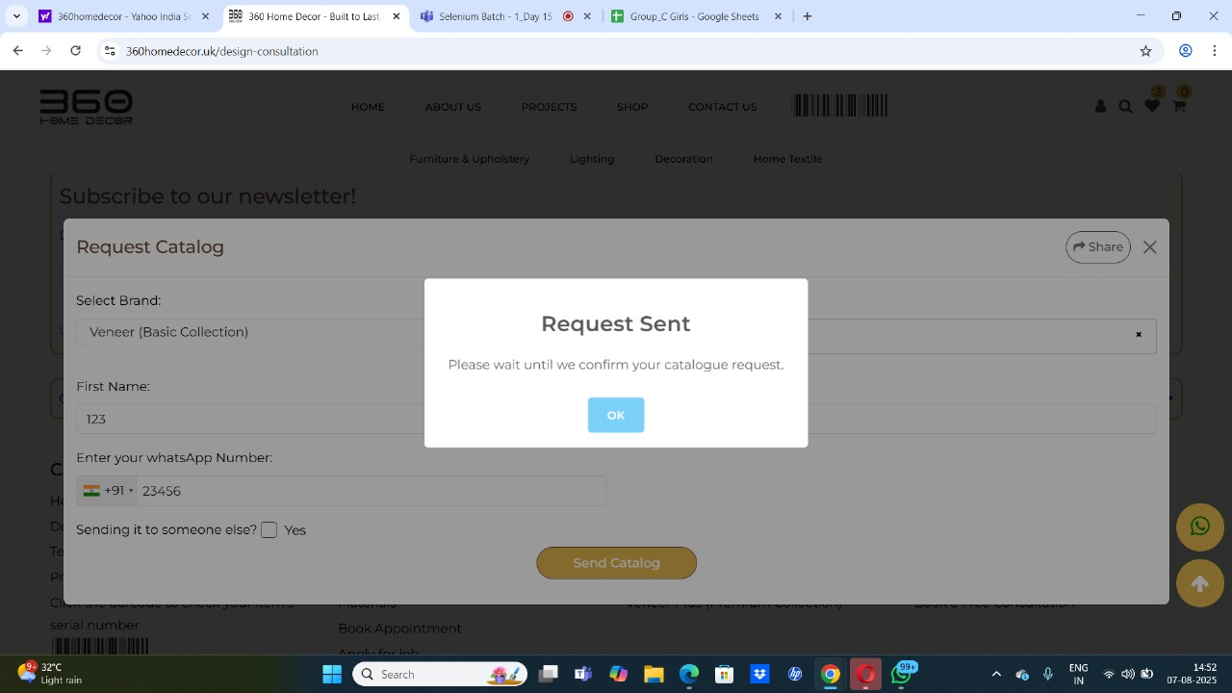

10. TC_APPLY_JOB_SUBMIT_TEST_01 <https://360homedecor.uk/career-test>

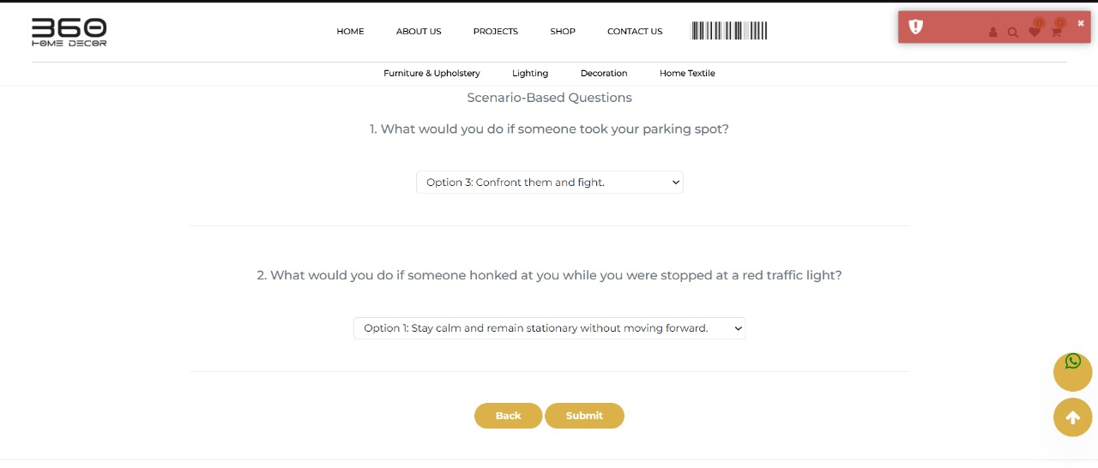

while we are not clicking any answer it goes to next tab

**11. TC_Menu_01** [**https://360homedecor.uk/share-modal/requestModal=1**](https://360homedecor.uk/share-modal/requestModal=1)

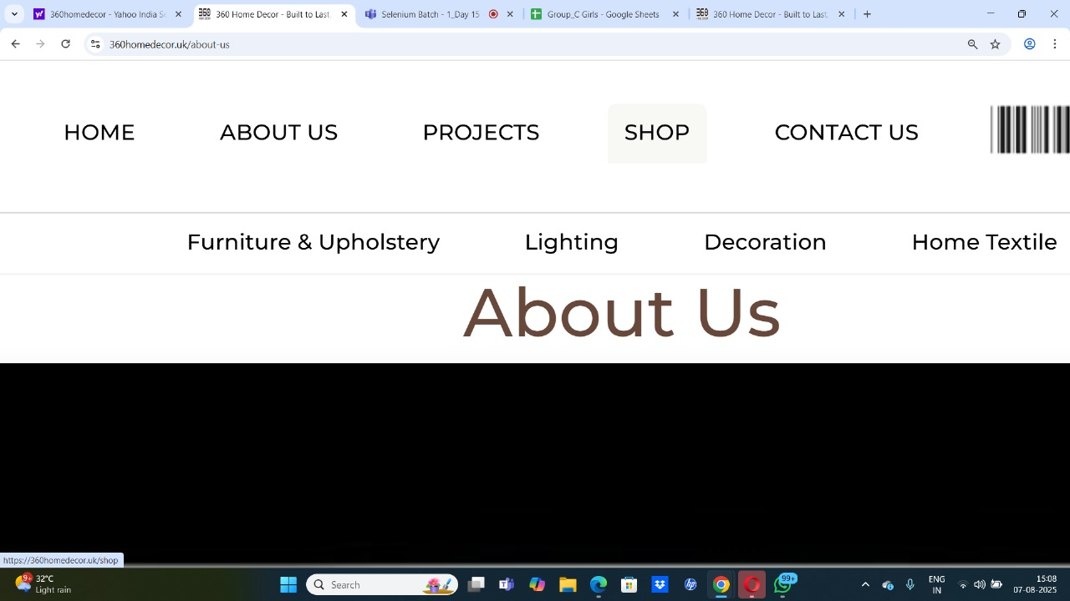

after clicking on shop it is hovering but same is not working in Home, About us and projects.